Minutes of the Joint Budget Committee & Human Resources Committee Meeting
December 16, 2024

The Budget Committee and Human Resources Committee met jointly on Monday, December 16, 2024 at 5:30 p.m. in the Executive Conference room at the Williamson County Administrative Complex.

Budget Committee members present were: Chairman Judy Herbert and Commissioners David O’Neil, Megan Guffee, Mary Smith and Mayor Rogers Anderson.

Human Resources Committee members present were: Chairman Paul Webb and Commissioners Betsy Hester, Meghan Guffee, Drew Torres and Brian Clifford. Commissioner Gregg Lawrence was unable to attend.

Also present were: Steven Thompson, Consultant with BTA & Associates; Sheriff Jeff Hughes; Captain Freddie Moore; Captain Leonardo Zollicoffer; Captain Chad Youker; Clair Cochran, HR director; Sarah Bullock, legal counsel with Buerger, Moseley and Carson; Diane Giddens, Chief of Staff; Phoebe Reilly, Budget & Finance Director; Commissioners Beathard, Tunnicliffe and Petty; Zannie Martin, Juvenile Services Director; Ondrea Johnson, Animal Center Director; Conner Scott, Public Safety Director; Todd Horton, Emergency Management Director; Kristy Borden, Emergency Communications Director; Jeff Whidby, County Clerk; Sherry Anderson, Register of Deeds; Bethany Tucker and Karla Roos with the Human Resources Department; Creed Henderson, WCTV Director; Jennifer Davis, Sheriff’s Office Accounting Manager; Karen Paris, Trustee; Gordon Hampton, Parks and Recreation Director; Mary Spain, Payroll Director; Jason Golden, WCS Superintendent; Rachel Farmer, WCS Assistant Superintendent of Budget and Finance; Office; Amanda Jones, Assistant Library Director; Debbie McMillian Barrett, General Sessions Court Clerk; Brian King, WCS Assistant Superintendent of Operations; and other interested individuals.

Budget Committee Chairman, Judy Herbert called the Budget Committee meeting to order at approximately 5:30 pm.

Human Resources Chairman, Paul Webb, called each the Human Resources Committee meeting to order.

Citizen’s Communication: Budget Committee Chairman, Judy Herbert, retrieved the sign-in sheet that was placed at the entry door 10 minutes before the meeting. She stated that there were no signatures on the form and no one in the room that wished to address the Committees. Chairman Herbert then closed the Citizen’s Communication portion of the meeting.

Minutes:

Budget Committee: November 4, 2024: Commissioner Guffee made a motion to approve the November 4, 2024 Budget Committee Meeting Minutes, as submitted. Commissioner O’Neil seconded the motion. The motion passed with a vote of 5-0.
Human Resources Committee: October 21, 2024: Commissioner Torres made a motion to approve the October 21, 2024 Human Resources Committee Meeting minutes, as submitted. Commissioner Hester seconded the motion. The motion passed with a vote of 4-0.

Commissioner Brian Clifford arrived at approximately 5:36 pm.

Mayor Anderson recognized, Mr. Steven Thompson, consultant with BTA & Associates, who was contracted to conduct an employee compensation study for the county’s full-time employees, excluding WCSchool personnel. Mayor Anderson noted that the current fiscal year included a 4% salary increase beginning in July, 2024, and an additional 2% forthcoming in January, 2025. However, he noted that it is important for the county to remain competitive so as to lessen the amount of turnover.

Joint Budget & Human Resources Committee
Meeting – December 16, 2024
Page Two

Mr. Thompson reported that the study included approximately 1,200 full time positions to ensure the county’s pay structure, pay grades and ranges were in a position that was competitive with same positions and classifications in surrounding and similar governments.

He continued that he compiled market data from similar population and surrounding counties including some in east Tennessee, as well as the cities of Brentwood, and Franklin and others. He stated that he also does compensations consulting for these various counties and municipalities.

In comparing Williamson County salaries, he has concluded that Williamson County is in the 65 percentile, meaning that 35% of the positions are higher.

Sheriff Hughes noted that he is losing personnel to the State, as well. He expressed his appreciation to Mr. Thompson, Mayor Anderson and Human Resources Director, Clair Cochran for this study and the work they are doing to ensure the county can retain personnel.
Mayor Anderson explained that all Commissioners need to begin thinking about budget guidelines that are needed for the 2025-26 fiscal year for the County and WCS. These guidelines will need to be approved during the next Budget Committee Meeting.

Upon Mayor Anderson’s inquiry, Phoebe Reilly reported that for every 1% pay increase for the county, it requires $1.8 million and School Finance Officer, Rachael Farmer reported $4 million.

Committee members reviewed a synopsis of the compensation report showing the funding totals needed to implement the study, as follows:

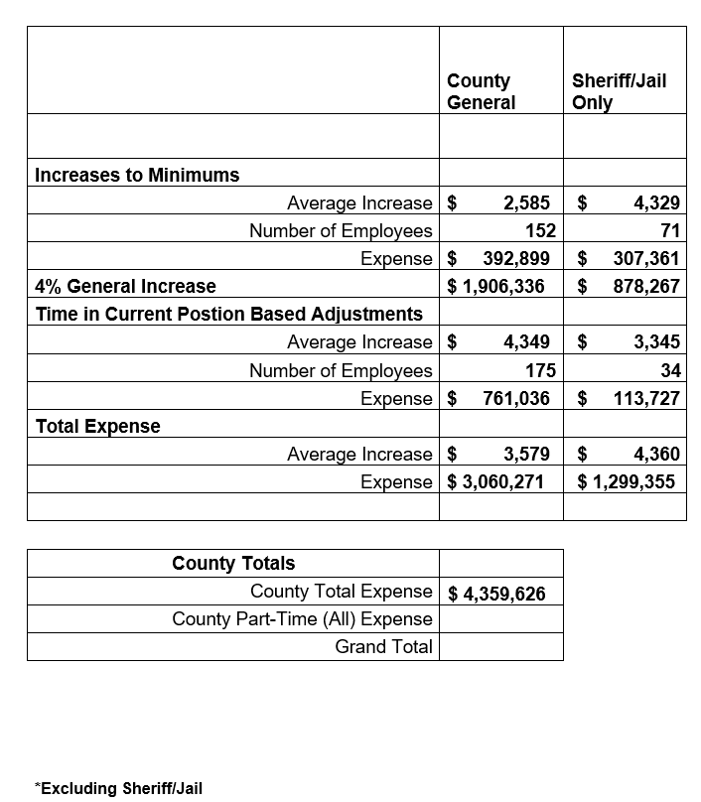

Joint Budget & Human Resources Committee
Meeting – December 16, 2024
Page Three

Discussion was held regarding revenue availability in preparing for the 2025-26 fiscal year budget.

Sheriff Hughes stated that he is aware this is an on-going process and that he had some command staff changes forthcoming; however, he is comfortable with the funding as outlined to be able to do what he would like to implement.

Mayor Anderson stated that if there are no objections from committee members on either side, this would be the guidelines to be presented to the department heads and elected officials moving forward for their budget preparation. He stated that this will allow sufficient funds to address the Sheriff’s needs, implement the compensation study results and provide a minimum 4% salary increase for all full-time employees.

There were no objections from committee members.

There being no further busines, the Joint Budget Committee and Human Resources Committee meeting was adjourned at approximately 6:45 p.m.

/jd

